Paper 1: https://www.sciencedirect.com/science/article/pii/S2468502X17300013#bb31
Visual Simulation of Clouds:
This paper talks about multiple methods to approach the modelling, rendering and animation of clouds. This paper includes references to many other papers as well.

Typically two ways to model clouds: Procedural and physically.
Procedural is the most popular approach, often using some kind of noise function - someone even used fractals to model clouds. Gardner proposed textured ellipsoids for a visual simulation. Ebert et al. used metaballs and a noise function. Spectral synthesis was also used. I dont know much (if anything) about these topics, but included them in here anyways.
Physically: atmospheric fluid dynamics is a numerical approach for modelling cumulonimbus clouds. Kajiya and Herzen
atmospheric fluid dynamics -Kajiya and Herzen
Couple-map Lattice - Miyazaki et al.
^extended version of cellular automata
Problem: Computation cost is very high
These methods are better suited to animating clouds as well.

Cloud generation from images:
Can only generate cirrus, altocumulus, and cumulus.
Each of the three clouds above are generated in different ways
Cirrus Clouds- These are modelled as a 2d texture as self shadows are rarely observed
Altocumulus- Self shadows are observed, so a three dimensional density distribution is define. They used meta balls to define the density distribution, the values of which were determined using the intensity and opacity information.
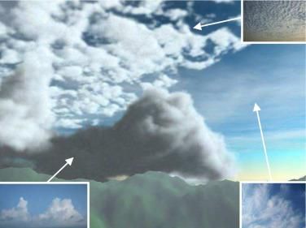
Cumulus Clouds- initially a surface shape is generate of the clouds by calculating a thickness at each pixel by using opacity information. Density inside the shape is then generated, employing a procedural approach.

Fig. 2. Modeling of clouds from photographs. Three types of clouds in the synthetic image are modeled from the corresponding photographs shown in the inset images.

Offline Rendering:
Offline - as in not real time (?)
I kind of zoned out reading this. Will read again and fill this out hopefully.

